Цветовая гамма RANNILA (RaColor) кровельных саморезов
 RR20 - WHITE
 RR21 - LIGHT GREY
 RR22 - GRAY
 RR23 - DARK GRAY
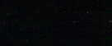 RR33 - BLACK
 RR27 - RED
 RR28 - DARK RED
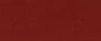 RR29 - RED
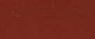 RR730 - TILE RED
 RR30 - LIGHT BROWN
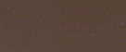 RR31 - BROWN
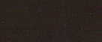 RR32 - DARK BROWN
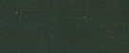 RR11 - SPRUCE GREEN
 RR34 - LIGHT BLUE
 RR35 - BLUE
 RR36 - LIGHT GREEN
 RR37 - GREEN
 RR38 - GREEN

